

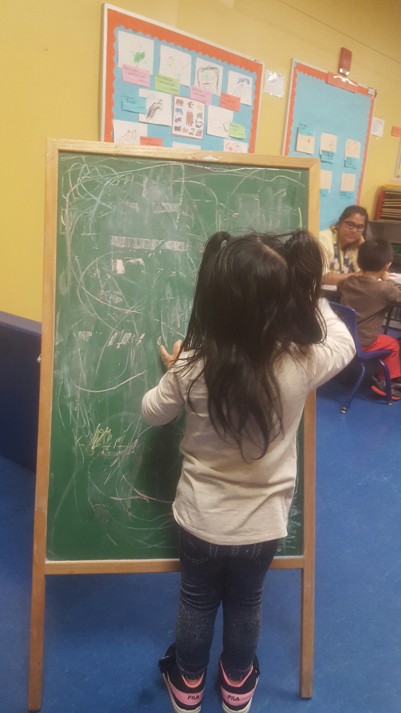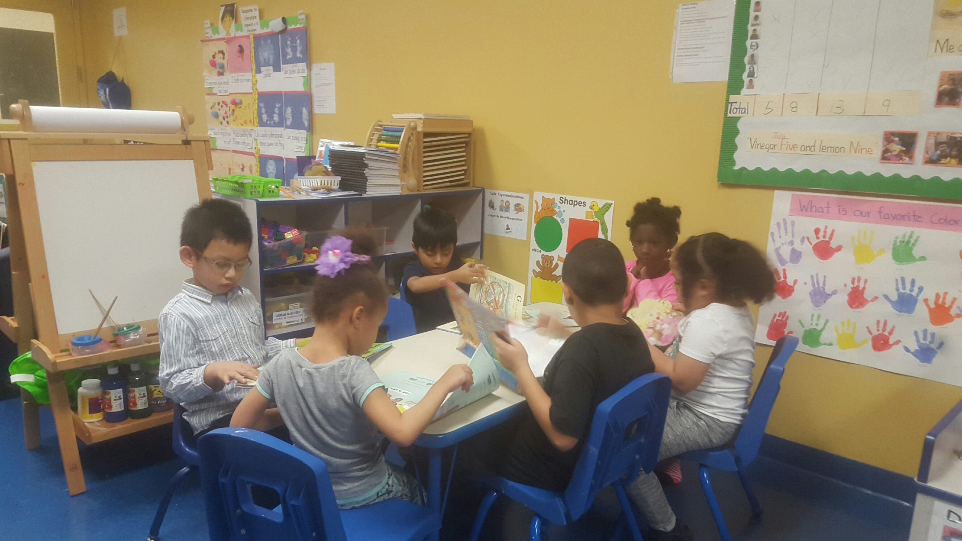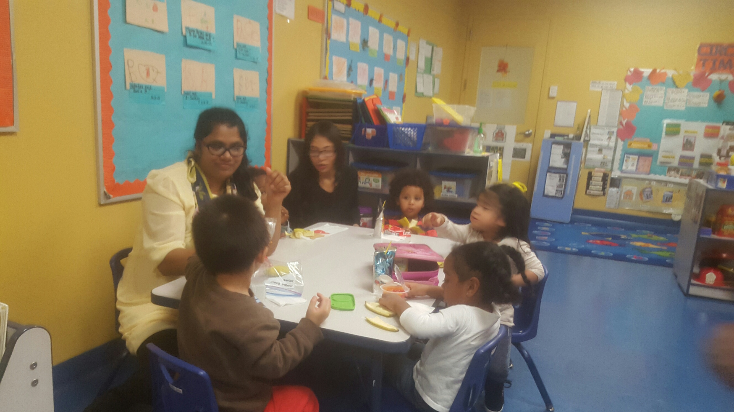

[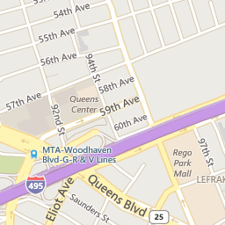](http://www.google.com/url?sa=i&rct=j&q=&esrc=s&source=images&cd=&cad=rja&uact=8&ved=&url=http://www.weichertrents.com/NY/Queens/Rego_Park/Lefrak_City/&psig=AFQjCNHDhWgd9ejDiS38ou5uE_DFceGz1g&ust=1452019845913108)

95-15 Horace Harding Expressway

Corona, NY 11368

718-271-2294  
WWW.SESAMESPROUTSCHOOL.COM

**Bring this coupon for a**

**15%**

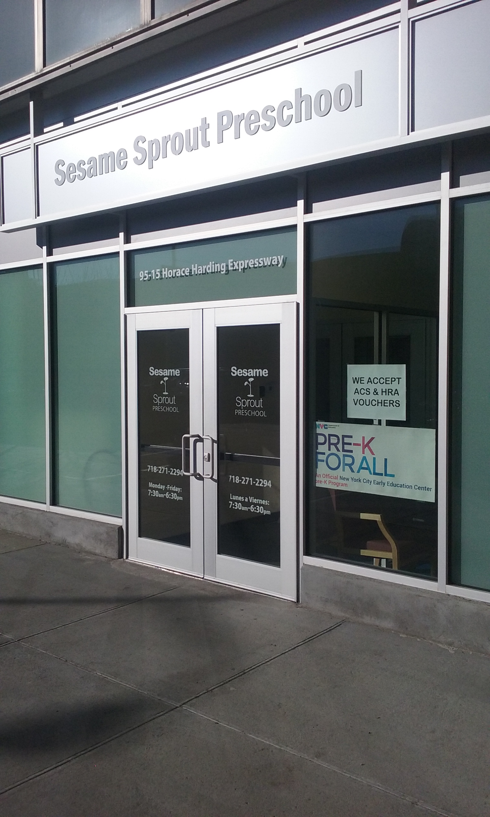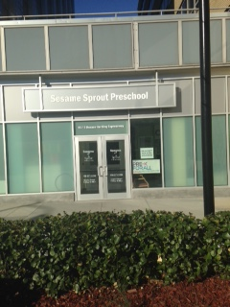

Located at



**We Encourage Our Children to Reach Their True Potential**

**PKA**

**ACS / Private Care**

**Summer Camp**

**Afterschool**

**Open House**

**Tour our school* Check our classrooms * Meet our teachers**

**Save the date**

**December 18 and 19, 2017**

**10:00 am- 3:00 pm**